# 2022 July 21th

Today is a bad day. It seems to be that I have done nothing.

I meet some difficulties:

1. The conflicts generated from the difference between redis and netty
2. Fail to connect to the redis

I complete some tasks:

1. Design the database probably.
2. Think about how to use the redis and have a better knowledge of the relationship between mybatis and redis.

I understand something and sum up some experience:

1. We should try to find the root of problem from the tips given by idea.
   1. Catch the key word
   2. The key reason which is always mentioned in the last sentence.
   3. My be there is the version conflict.
2. How to design the database
   1. Inherit and derive can help us protect the safty of data
      1. General information can be the parents.
      2. The next time we seek for a entity by using the related table in database, we can just return a general class to hide the important data instead of entire class.
   2. How to use the RBAC to create the permission.
   3. Each class is divided and we can create the new classes to adapt to the new demand.

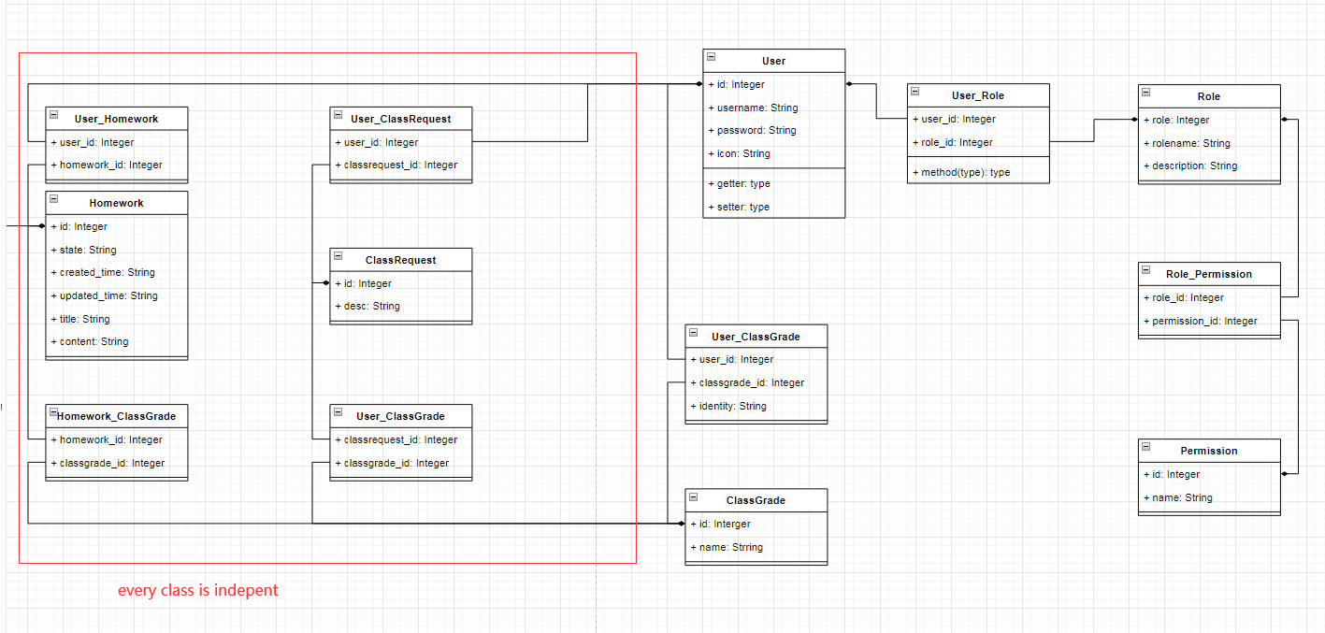

Tomorrow

# 2022/9/24

Redis 如何保证原子性来应对并发访问？

1. 原子操作
   1. 单命令操作，比如redis自带的 incr/decr就可以实现数据的删减操作
   2. Lua脚本，封装多个复杂命令在Lua脚本中，redis会把整个Lua脚本作为一个整体执行。但是容易导致redis执行脚本的成本增加，降低并发性能
2. 分布式加锁
   1. 锁操作的原子性，我们可以采用单命令操作或者是Lua脚本来保证加锁的原子性，释放锁时我们只需要直接删除就可以了；
   2. 分布式锁的可靠性，比如我们需要给锁设置一个过期时间，放置一个线程发生异常后长期占有锁而不释放；给锁定义一个唯一的ID，避免过期释放锁后，线程执行完事务又重新释放别人的锁。

# 2022/9/25

1. 避免了将学生重复导入到班级中
2. 避免了布置作业没有上传文件的问题
3. 查看未提交的作业

# 2022/9/28

待完成列表：

1. 学生端和教师端消息列表
2. 教师端批改作业
3. 预览作业

# 2022/9/29

1. 作业详细信息列表初步完成

# 2022/9/30

1. 批改作业完成

# 2022/10/5

1. 聊天功能完成
2. 聊天记录存储mysql